**Hands-on Activity**

**Neutrinos as pieces of the Standard Model of particle physics**

**Learning goals**

Learn what matter is and what are the fundamental forces of nature.

Describe forces as the interaction between two particles: what makes an interaction possible?

Identify neutrinos as very unique particles: tiny and neutral, and only interacting through the weak force.

**What’s needed**

At least, one particle badge per student participating in the activity. If there are fewer students than particles, each student can be given two to three particle identities.

Other resources that might be useful: a table of interaction properties, a table of the Standard Model of particle physics ([link](http://www.cpepphysics.org/images/2014-fund-chart.jpg)), a short description of the Standard Model ([link](http://home.web.cern.ch/about/physics/standard-model)).

**List of cards provided**

Quarks (up, down, charm, strange, bottom, top), leptons (electron, electron neutrino, muon, muon neutrino, tau, tau neutrino), force carriers (photon, Z boson, W+ and W- bosons, gluon), Higgs boson, and matter (quarks and leptons) antiparticles.

PDF and InDesign files can be found [here.](http://go.wisc.edu/a3qi7z)

Depending on the number of students, you could make two to three copies of the following particles: up and down quarks (to build protons and neutrons) and neutrinos, especially muon neutrinos. You could also print a few more antiparticles.

Interaction cards, with examples of strong, electromagnetic and weak interactions.

**Activity proposal**

Students are given a badge with one (or more) particle identity. They will wear this badge in a way that other students can see the name of their particle(s).

Beginning with questions/suggestions by teachers or from their own proposals, students will behave like the particle(s) they have been assigned. The following questions/exercises can be adapted based on the time available and the prior knowledge of the students.

This activity could last from 20 to 90 or more minutes, depending on how deep you go into the Standard Model of particle physics. However, we would suggest about 30 minutes when used as a hands-on activity to learn about what a neutrino is and how unique its properties are.

1. The particles and their main properties

* **We would like to get the students familiar with elementary particles. Teachers will ask them to introduce the particle(s) they will be portraying during this activity: i.e., they should say the name and group of their particle as well as its main properties (see image below).
* Students will be asked to group themselves in families/types of particles. All fermions on one side, all bosons on another. Within fermions, leptons and quarks will form different groups. The Higgs boson and the graviton might be identified as special bosons.

1. Matter and forces

* Students stay in their recently formed groups. Either as an all-hands discussion or as a discussion within a group, students will be required to link the particles they portray with their knowledge about matter and the forces of nature.

Matter, as we usually call it, is formed by electrons, protons and neutrons. Protons and neutrons are made up of 3 quarks that can only be either up or down quarks. Students should figure out how to create a proton and a neutron taking into account that a proton has a positive electrical charge +1 and the neutron is neutral, i.e., electrical charge = 0.

Forces. Students will identify the four forces of nature and link them to the particle carriers.

Why are forces associated with boson particles, also called force carriers? Teachers will guide students to the idea that modern physics explains matter as something made up of elementary particles and forces as the results of the interaction of matter with another type of particle called a force carrier.

Students will realize that all force carriers are bosons, but that there are two special bosons.

The graviton has a question mark, since it’s the only boson not yet discovered. Teachers can offer that modern physics has managed to explain all interactions with quantum theories, with the exception of gravity, which so far is not a quantum interaction. Gravity is explained through the theory of General Relativity, by Einstein, which works pretty well. But many physicists think that all interactions should be explained by a quantum theory. If this is true, they call the graviton the carrier of the gravitation force.

The Higgs is marked with some white pattern on its frame. This is because, as far as we know, the Higgs is not a force carrier, but its existence explains why some particles have mass. It is a special boson, but we still do not understand how different it is from other bosons and how this can affect our current understanding of matter and forces.

Students will realize that matter particles are fermions, but that there are more fermions than those that build up standard matter (i.e., electrons and up and down quarks). What are the other fermions?

Teachers will guide students to understand that matter, as scientists understand it, is made up of fermions. Some of these fermions exist on Earth—like electrons and up and down quarks, but also like neutrinos—while others only existed during the early stages of the universe or are created in high-energy interactions, either in laboratories on Earth or in nature.

1. Interactions in nature and how they relate to particle properties

* Teachers will guide students into a discussion about the forces of nature. Are they all equally strong? Do all matter/particles feel them?

It would be good to identify each particle with at least one known effect: e.g., (1) gravitation, bodies falling; (2) strong force, protons remaining inside a nucleus; (3) electromagnetic, atoms forming structure of matter, e.g., the wood of a table; (4) weak, things “falling apart” or decaying.

We should order them from the strongest to the weakest: strong, electromagnetic, weak and gravity.

* Using the students’ knowledge about the electromagnetic interaction and the properties on the back of the cards, teachers will guide the group to the idea that each interaction is associated with one kind of charge: electric charge🡪 electromagnetic; flavor 🡪 weak; color 🡪 strong; mass 🡪 gravity.

We will choose a force carrier and ask the student to come to the center of the room. Then, we will ask all the other particles, force carriers included, to group around the selected force carriers only if they interact with it.

We can also ask a few students to tell us which interaction they can feel and why. Previously, we might have asked all the students to write on the back of their badges which interaction they can feel.

* Now students are ready to produce their own interactions. We will use simple Feynman diagrams to explain how an interaction works. In these diagrams, time flows from left to right. On the left, the particles that will interact are displayed. In the middle we can see the force carrier, which tells us what kind of interaction is taking place. On the right, we find the outcomes of the interaction. In the one displayed below, an electron neutrino interacts weakly with an electron, creating a new pair of an electron neutrino and an electron.

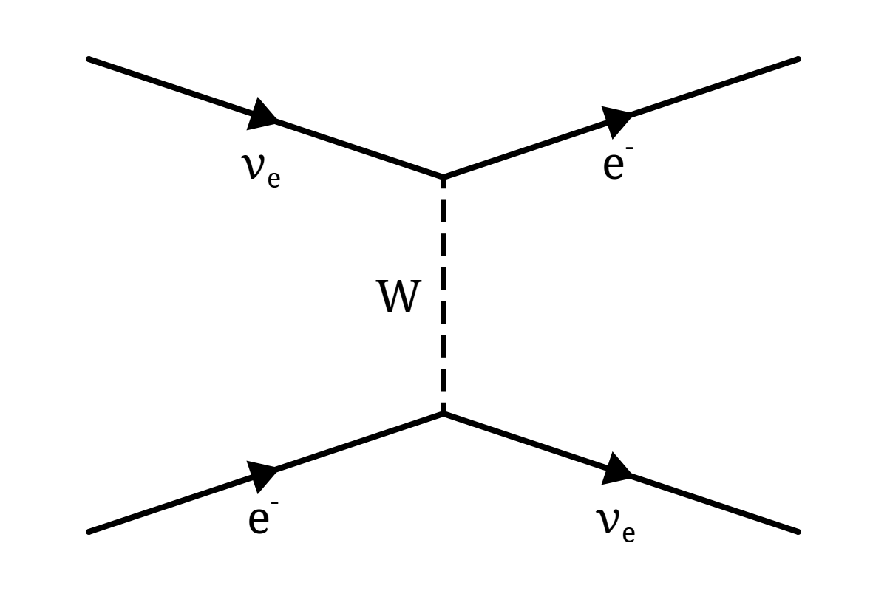

Teachers will guide students to understand what makes each interaction possible. These are the concepts that could be explained, with probably increasing difficulty for the student:

1. For a given force carrier, the interacting particles need to have the right properties.

a.1.- In an electromagnetic interaction, i.e., mediated by a photon, particles are electrically charged.

a.2.- In a strong interaction, i.e., mediated by a gluon, particles have color.

a.3.- In a weak interaction, i.e., mediated by a Z or W boson, particles have flavor.

b) At each vertex of the Feynman diagram charge, flavor and color are conserved. For example, if an incoming particle is neutral, the two other elements at the vertex are either both neutral or one positive and one negative.

c) Since energy also needs to be conserved, interactions mediated by a heavy particle are less likely to happen. This is, for example, why neutrinos hardly ever interact with anything. First, they only interact weakly. Second, they have a very low mass, so even these interactions hardly ever happen.

We can also ask students to draw/represent an impossible interaction, and explain why, based on what they have just learned (e.g. have a strong interaction between two leptons, or an electron-positron interaction that ends with a neutral and a positive/negative particle).

1. Neutrinos as very unique particles

* IceCube explores the universe with neutrinos instead of light (i.e., photons). But, what makes neutrinos such interesting particles? Teachers will guide students to learn that neutrinos are the lightest particles with mass and the only ones that only interact weakly (they also feel gravity, but their mass is very, very small).

Teachers will ask all particles with mass to come to the center of the room. Students will check which particles are in the group and will identify the particles with the largest and smalles mass.

Now, teachers will ask all particles that interact strongly to leave the group. Students will check which type of particles left the group.

This time, teachers will ask all particles that interact electromagnetically to leave the group. Again, students will check which type of particles left the group.

* The neutrino will be the only particle remaining. Teachers will guide a discussion about the properties of the neutrino with respect to other known and abundant particles in the universe.

Teachers will ask students to name a few abundant particles: electrons, protons, and photons are the answers we would like to get. Neutrinos are also abundant.

Lets imagine a cosmic object, a powerful extreme environment, is creating all these “cosmic messengers,” i.e., sending to Earth—and to other places in the universe—electrons, protons, photons and neutrinos.

What happens to electrons and a protons? They are charged particles; they feel the electromagnetic force. They will bend when crossing magnetic fields in the universe, such as around stars in our galaxy and beyond. If they happen to find anything in the middle of their way, they will interact and be absorbed.And when the electrons or protons reaches the Earth? They immediately interact with the Earth’s atmosphere.

What happens to a photon? It can travel in a straight line, because it’s neutral. If it happens to find anything in the middle of its way, it will interact and be absorbed. It’s the electromagnetic force carrier, it interacts with all charged particles.When it reaches the Earth, it will immediately interact with the Earth’satmosphere.

What happens to a neutrino? It can travel in a straight line, because it’s neutral If it happens to find anything in the middle of its way, it has a great chance of just passing through it without feeling it. It does not interact electromagnetically, nor strongly. As it only interacts weakly, it really needs to jump into another particle. When it reaches the Earth, it will cross the atmosphere and even the entire Earth with only a small chance of interacting.

If we can catch some of these elusive neutrinos, they will point to the sources where they were created! It’s not easy though. We need detectors with a volume of one cubic kilometer, or larger. IceCube is the first detector of this kind, and so far the only that has observed neutrinos from outer space.

1. Building the Standard Model of particles and forces

* Teachers will ask students to built a simplified chart of the Standard Model. Particles of matter (fermions) and force carriers (bosons). Plus the special Higgs boson. They will add the forces (strongest on the left, weakest on the right) and identify the relevant force carriers and charges.